1xx - Controls | 2xx - Ground | 3xx - Flight | 4xx - A2A | 5xx - A2G | 6xx - Misc
300a - Flight - Symbology guide IHADSS, HAD

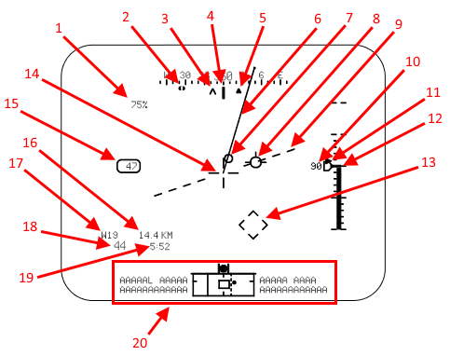
IHADSS Transition mode:
- Engine Torque percent
- FCR LOS??
- For PLT: Next waypoint heading or bob-up heading
For CPG: TADS LOS bearing
- "Lubber Line"; aircraft current heading/centerline
- Other crewmember LOS bearing
- Velocity vector
  - Ground speed and direction. In Hover/Bob-Up shows 0-6 kts; in Transition/Cruise shows 0-60 kts.
- Acceleration cue
- Flight path vector
- Horizon line
- Radar altitude
- Climb rate (filled triangle), 100 fpm tics, 0-±1000 fpm
  - Outlined "home plate" marker indicates Altitude Hold setting.
- Radar altitude tape, 10 ft tics, 0-200 ft
- Head Tracker (aircraft centerline??)
- LOS reticle
  - Dots at ends of reticle bars show direction toward cued LOS reticle (dashed crosshair, not shown in this image).
- True airspeed (if boxed, indicates Attitude Hold mode active)
- Distance to go to destination waypoint
- Destination waypoint
- Ground speed
- Time to go to destination waypoint
- HAD (High Action Display), see below

High Action Display (bottom of HDU)
